ARCHITECTURE

OF LIBRARY MANAGEMENT SYSTEM

**1. General System Architecture**

The architecture of applications is usually broken into logical chunks called "tiers", where every tier is assigned a role. A “tier” can also be referred to as a “layer”. There are three layers involved in the application namely Presentation Layer, Business Layer and Data Layer. Each layer is explained in detailed below:

**Presentation Layer:**

It is also known as Client layer. Top most layer of an application. This is the layer we see when we use a software. By using this layer, we can access the webpages. The main functionality of this layer is to communicate with Application layer. This layer passes the information which is given by the user in terms of keyboard actions, mouse clicks to the Application Layer. For example, login page of Gmail where an end user could see text boxes and buttons to enter user id, password and to click on sign-in. In simple words, it is to view the application.

**Application Layer:**

It is also known as Business Logic Layer which is also known as logical layer. As per the Gmail login page example, once user clicks on the login button, Application layer interacts with Database layer and sends required information to the Presentation layer. It controls an application’s functionality by performing detailed processing. This layer acts as a mediator between the Presentation and the Database layer. Complete business logic will be written in this layer. In simple words, it is to perform operations on the application.

**Data Layer:**

The data is stored in this layer. Application layer communicates with Database layer to retrieve the data. It contains methods that connects the database and performs required action e.g.: insert, update, delete etc. In simple words, it is to share and retrieve the data.

**2. Database Architecture**

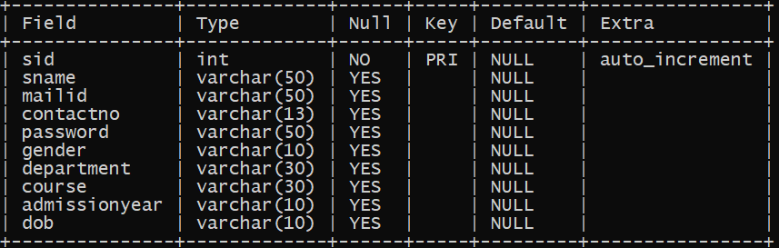Student Table:

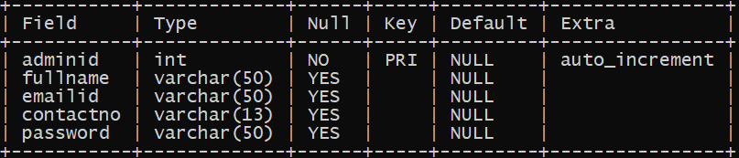Admin Table:

Bookslimit Table:

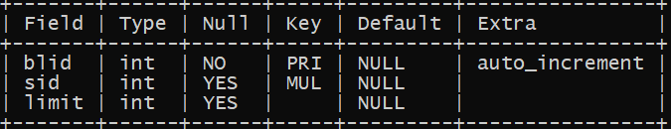

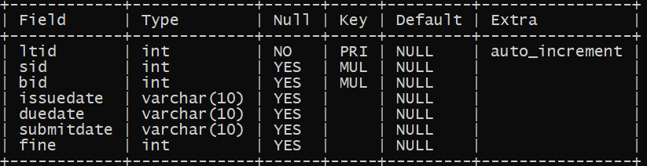Library_Transactions Table:



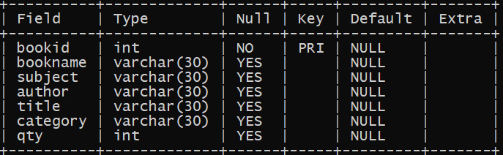

Books Table:



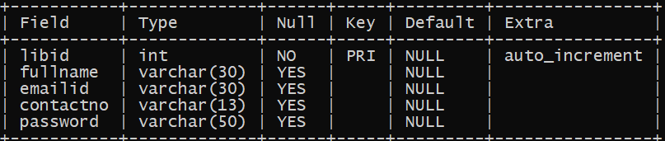Librarian Table:

**3. Package Architecture and Flow**

**Client**



**Request Sent as DTO**

**Response**

**Request**